**Assignment 9: Create a Chatbot Application for Any Real-World Scenario**

**Problem Statement**

The objective of this assignment is to develop a chatbot application tailored for a specific real-world scenario, such as customer service or health advisory. The chatbot will utilize natural language processing (NLP) to understand user queries and provide relevant responses.

**Objectives**

* Understand the structure and implementation of chatbots.
* Create a chatbot that can handle a specific real-world scenario effectively.

**Theory**

**What is a Chatbot?**

A chatbot is an artificial intelligence program designed to simulate conversation with human users, especially over the Internet. It uses natural language processing (NLP) to understand user queries and provide appropriate responses based on pre-defined intents and dialogues.

**Methodology**

1. **Define User Intents and Corresponding Responses**:
   * Identify the specific intents or topics the chatbot will handle. For example, in a customer service scenario, intents could include "Order Status," "Return Policy," "Product Information," etc.
   * Create a set of predefined responses for each intent.
2. **Use NLP Libraries or APIs to Process User Queries**:
   * Implement NLP techniques to parse and understand user input. Libraries such as NLTK, spaCy, or popular APIs like Dialogflow, Microsoft Bot Framework, or Rasa can be used for this purpose.
3. **Implement Logic to Map User Queries to Intents**:
   * Create a mechanism to analyze the user’s query, identify its intent, and provide the corresponding response. This may involve using techniques like keyword matching, machine learning classification, or rule-based systems.

**Working Principle / Algorithm**

Here’s a simple outline of how to implement a chatbot:

1. **Initialize the Chatbot**:
   * Set up the environment and load the necessary libraries or APIs.
2. **Define Intents and Responses**:
   * Create a structure (e.g., dictionary) that maps intents to their respective responses.
3. **Process User Input**:
   * Capture user input through a user interface (e.g., web page, messaging platform).
   * Use NLP techniques to preprocess and analyze the input (e.g., tokenization, stemming).
4. **Identify the Intent**:
   * Compare the processed input against predefined intents and select the best match based on similarity scores or rules.
5. **Provide Response**:
   * Retrieve the appropriate response based on the identified intent and send it back to the user.
6. **Loop for Continuous Interaction**:
   * Keep the conversation going by allowing users to ask follow-up questions or change topics.

**Advantages**

* **Automated Assistance**: Chatbots provide real-time assistance without the need for human intervention, improving efficiency and user satisfaction.
* **24/7 Availability**: They can operate around the clock, offering support at any time.

**Disadvantages / Limitations**

* **Limited Understanding**: Chatbots may struggle with complex or ambiguous queries that fall outside predefined intents or responses.
* **Dependence on Quality of Data**: The effectiveness of a chatbot heavily relies on the quality and comprehensiveness of the training data and defined intents.

**Diagram**

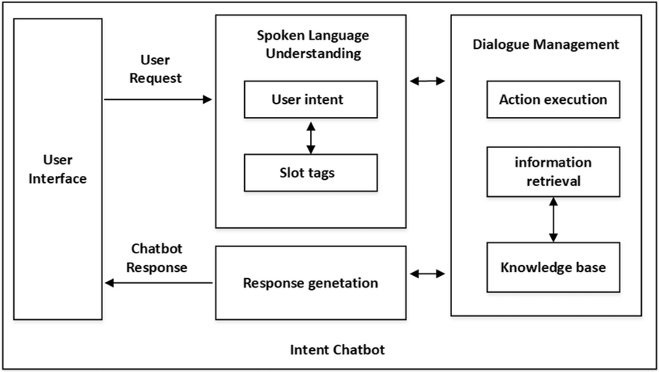

**Conclusion**

Chatbots represent a practical application of AI that can automate real-world tasks, providing interactive and automated assistance to users. By leveraging NLP and structured dialogue management, chatbots can effectively serve various domains, enhancing user experience and operational efficiency.